NIST Normative Test Process Document: eDOS-LIS Test Tool for Transmission of Laboratory Order Compendium to EHR-S

Test Tool and Test Descriptions to Conduct HIT Conformance Testing
NIST Approved Version 1.2
Date: September 14, 2016

Developed by the National Institute of Standards and Technology (NIST) in collaboration with the Association of Public Health Laboratories (APHL) and the Centers for Disease Control and Prevention (CDC)

List of Contents

Conformance Criteria

Description of the specifications for conformance testing

Explanation of Terms

A table containing a key of equivalents for names and terms used frequently in this document

Informative Test Description

Key background information for conducting the conformance testing; includes information about
- Definition of “Tester” for this document
- Care settings and profiles that are in-scope for the testing
- Capabilities the Health IT Module must be able to demonstrate during the conformance testing

Normative Test Description

Detailed description of the testing process, including Derived Test Requirement(s), Testing Workflow Diagram(s), Required Vendor Information, Required Testing Actions, and Inspection Test Guide

Test Data

Detailed description of the purpose and use of the provided test data, including allowed exceptions

Navigating a Test Case

Detailed description of the information and instructions available in the NIST Test Tool related to the Test Cases

How to Interpret the Message Content Data Sheet

Detailed description of the purpose of and information available in the Message Content Data Sheet, including the meaning of the NIST Test Data Categories

Conformance Test Tools

Links to the web-based NIST Test Tool and Support sites

Document History

Listing of Version Numbers and Publication Dates for the final published versions of the NIST Testing Process document

NIST Normative Test Process Document for eDOS-LIS: Transmit laboratory order compendium to EHR-S
This document describes the testing process for which a National Institute of Standards and Technology (NIST) validation test tool is used in evaluating conformance of a health information technology module (Health IT Module) in creating HL7 laboratory order compendium (electronic Directory of Services – eDOS) messages for transmission to EHR technologies in accordance with the HL7 Version 2.5.1 Implementation Guide: S&I Framework Laboratory Test Compendium Framework R2, DSTU Release 2 - US Realm, September 2015 interoperability standard and, at a minimum, the LOINC version 2.50 vocabulary standard.

Conformance Criteria

Create laboratory order compendium (eDOS) messages
Health IT Module (e.g., an LIS or EHR-S laboratory module) must be able to electronically generate:
- Messages for creating a new laboratory order compendium conforming to the HL7 Version 2.5.1 Implementation Guide: S&I Framework Laboratory Test Compendium Framework R2, DSTU Release 2 - US Realm, September 2015 interoperability standard, and (at minimum) the LOINC version 2.50 vocabulary standard
- Messages for updating an existing laboratory order compendium conforming to the HL7 Version 2.5.1 Implementation Guide: S&I Framework Laboratory Test Compendium Framework R2, DSTU Release 2 - US Realm, September 2015 interoperability standard, and (at minimum) the LOINC version 2.50 vocabulary standard

Explanation of Terms

Key for Names and Terms Used Frequently in this Document
Referenced Names and Terms | Equivalent Used in Document
HL7 Version 2.5.1 Implementation Guide: S&I Framework Laboratory Test Compendium Framework R2, DSTU Release 2 - US Realm, September 2015 | “eDOS Implementation Guide” or “eDOS IG”
Logical Observation Identifiers Names and Codes (LOINC) version 2.50 | “LOINC” or “LOINC v2.50”
Health IT Module | “HIT Module” or “Module”
Laboratory Information System | “LIS”
Electronic health record system | “EHR-S”
NIST HL7 v2 Validation tool – Laboratory Test Compendium Framework R2 | “eDOS Test Tool” or “Tool”
Context-based LIS Test Plan | “Context-based eDOS-LIS Test Plan” or “eDOS-LIS Test Cases”

Informative Test Description
This section provides an executive summary describing how the NIST testing process is organized and conducted. The Understanding eDOS-LIS Messaging Conformance Testing document is available via the Documentation tab in the NIST eDOS Test Tool; this document is an additional resource that explains the process of Health IT Module conformance testing for HL7 v2 eDOS Messaging on the LIS sender side.

This document has been developed to be used by testers in conformance testing of Health IT Modules. The term “Tester”, when used in this document, refers to a person (such as a testing lab employee) acting on behalf of a testing lab or other entity for conformance testing of a Vendor’s HIT Module. In addition, a Vendor may use this document to test their own HIT Modules during development of their product and in preparation for conformance testing by a testing lab, and individual implementations of the eDOS IG may use this document when verifying conformance on the sender side.

The test evaluates the capability for a Health IT Module (e.g., an LIS or EHR laboratory module) to generate electronic HL7 order compendium messages that are conformant to the
- HL7 Version 2.5.1 Implementation Guide: S&I Framework Laboratory Test Compendium Framework R2, DSTU Release 2 - US Realm, September 2015 interoperability standard
- LOINC version 2.50 vocabulary standard

During the process of building the eDOS Test Tool, NIST discovered conformance requirements that were ambiguous in the named standards document. The “NIST eDOS Test Tool Implementation Decisions” document explains how they are interpreted in the Tool. This document can be accessed via the Documentation Tab on the eDOS Test Tool.

The eDOS Implementation Guide defines four message types that are relevant for conformance testing for each eDOS transaction; these message types are sent in the following order:

- MFN^M08^MFN_M08 – Master File Notification Test/Observation (“M08”)
- MFN^M10^MFN_M10 – Master File Notification Test/Observation Batteries (“M10”)
- MFN^M04^MFN_M04 – Charge Description Master File Message (“M04”)
- MFN^M18^MFN_M18 – Test/ Observation (Payer) Master File Message (“M18”)

The eDOS Implementation Guide defines four Acknowledgement message types that are relevant for conformance testing for each eDOS transaction:

- MFK^M08^MFK_M01 – Master File Acknowledgement Test/Observation
- MFK^M10^MFK_M01 – Master File Acknowledgement Test/Observation Batteries
- MFK^M04^MFK_M01 – Master File Acknowledgement Charge Description
- MFK^M18^MFK_M01 – Master File Acknowledgement Test/Observation (Payer) Master File Message

The eDOS IG defines two eDOS Profile options that are relevant for eDOS-LIS Context-based Validation. Each Profile option is identified either by a Pre-Coordinated OID or a combination of Component OIDs in MSH.21 (Message Profile Identifier):

eDOS Profile | Pre-Coordinated OID | Component OIDs | Component Name
EDOS_GU_Profile | 2.16.840.1.113883.9.70 | 2.16.840.1.113883.9.67 2.16.840.1.113883.9.68 | EDOS_Common_Component EDOS_GU_Component
EDOS_NG_Profile | 2.16.840.1.113883.9.71 | 2.16.840.1.113883.9.67 2.16.840.1.113883.9.69 | EDOS_Common_Component EDOS_NG_Component

The Context-based eDOS-LIS Test Plan in the NIST eDOS Test Tool includes three Test Scenarios with one to six Test Cases, each of which has four to eight Test Steps (and specific test data) for testing each Profile option. For the purpose of conformance testing, the Vendor must declare conformance to either the EDOS_GU_COMPONENT or the EDOS_NG_COMPONENT —only one is required. Test Cases with Test Steps are provided for each Profile option. Instructions regarding which Test Cases to use for each Profile option are provided in the Test Data section of this testing process document.

For this test procedure, the Tester shall execute all three Test Scenarios listed below and all of their associated Test Cases and Test Steps:

- EDOS 0: Smoke Test Case – minimally populated eDOS messages including Acknowledgements
Step 1: Initial upload of two individual observations (sent from LIS or EHR-S lab module)
Step 2: Acknowledgement (sent to LIS or EHR-S lab module)
Step 3: Initial upload of single panel test (sent from LIS or EHR-S lab module)
Step 4: Acknowledgement (sent to LIS or EHR-S lab module)
Step 5: Initial upload of charge code for a panel (sent from LIS or EHR-S lab module)
Step 6: Acknowledgement (sent to LIS or EHR-S lab module)
Step 7: Initial upload of a list of approved coverage for a panel (sent from LIS or EHR-S lab module)
Step 8: Acknowledgement (sent from EHR-S lab module)
- EDOS 1 – Initial Upload Test Case – maximally populated eDOS messages
Step 1: Initial upload of individual observations (sent from LIS or EHR-S lab module)
Step 2: Initial upload of panels and profiles (sent from LIS or EHR-S lab module)
Step 3: Initial upload of charge codes for orderable tests and panels (sent from LIS or EHR-S lab module)
Step 4: Initial upload of approved coverage information for orderable tests and panels for multiple insurance companies (sent from LIS or EHR-S lab module)
Step 5: Initial upload of limited coverage information for orderable tests and a panels for multiple insurance companies (sent from LIS or EHR-S lab module)
- EDOS 2 – Update Test Cases – typically populated eDOS messages
Deactivate
Step 1: Deactivate individual observation test that is no longer offered (sent from LIS or EHR-S lab module)
Step 2: Deactivate panel/profile test that is no longer offered (sent from LIS or EHR-S lab module)
Step 3: Deactivate charge codes of tests that are no longer offered (sent from LIS or EHR-S lab module)
Step 4: Update approved coverage information for deactivated tests (sent from LIS or EHR-S lab module)
Add
Step 1: Add new individual observation tests (sent from LIS or EHR-S lab module)
Step 2: Add new panels and their elements (sent from LIS or EHR-S lab module)
Step 3: Add charge codes for newly added individual tests and panels (sent from LIS or EHR-S lab module)
Step 4: Add approved coverage information for newly added tests and panels (sent from LIS or EHR-S lab module)
Revise
Step 1: Revise information about individual observation tests (sent from LIS or EHR-S lab module)
Step 2: Revise information about a panel (sent from LIS or EHR-S lab module)
Step 3: Revise charge codes for orderable individual tests and panels (sent from LIS or EHR-S lab module)
Step 4: Revise approved coverage information for a test (sent from LIS or EHR-S lab module)
Reactivate
Step 1: Reactivate information for individual observation tests (sent from LIS or EHR-S lab module)
Step 2: Reactivate information for panels and their elements (sent from LIS or EHR-S lab module)
Step 3: Reactivate charge codes for individual tests and panels (sent from LIS or EHR-S lab module)
Step 4: Update approved coverage information for reactivated tests and panels (sent from LIS or EHR-S lab module)
Update Combo
Step 1: Combination update – addition, revision, deactivation of information for individual observation tests (sent from LIS or EHR-S lab module)
Step 2: Combination update – addition, revision, deactivation of information for panels and their elements (sent from LIS or EHR-S lab module)
Step 3: Combination update – addition, revision, deactivation of charge codes for tests (sent from LIS or EHR-S lab module)
Step 4: Updates limited coverage information for orderable tests and panels; provides information for new lipid panel and an individual lipid test; deactivates arbovirus panel (sent from LIS or EHR-S lab module)
Revise postCombo
Step 1: Changes individual observation that was part of a previous update; makes non-orderable individual observation orderable (sent from LIS or EHR-S lab module)
Step 2: Changes a panel that was part of a previous update; revises the lipid panel (sent from LIS or EHR-S lab module)
Step 3: Changes a charge component that was part of a previous update; adds a CPT charge code for the new individual lipid panel (sent from LIS or EHR-S lab module)
Step 4: Changes limited coverage information for newly orderable tests and panels; updates information for the new individual lipid panel components and the revised panel (sent from LIS or EHR-S lab module)

These scenarios and the test data contained in them were developed by the Association of Public Health Laboratories (APHL) and the Centers for Disease Control and Prevention (CDC), in collaboration with NIST.

Test data documents, which are accessible from the NIST eDOS Test Tool identified in the Conformance Test Tools section of this testing process document, contain the test data that are specific to each Test Case. Instructions for use of the provided test data are listed in the Normative Test Description and Test Data sections of this testing process document.

Note: Regarding capabilities that are out-of-scope for the Health IT conformance testing
- The focus of conformance testing is on the ability of the Health IT Module to create conformant eDOS messages and is not on the operational aspect of transporting the messages.

Normative Test Description
Using the NIST eDOS Test Tool, conformance testing can be completed in either of the following two ways:
- Single message (step by step) eDOS-LIS testing
- Multiple message (multiple step) eDOS-LIS testing

Single message (step by step) eDOS-LIS testing is a separate validation of each message in an opened Test Case. After accessing the LIS Test Plan, opening either the GU or NG option, and then opening a Test Scenario and a Test Case, the Tester will select each of the Test Steps in their given sequence, will click on “Load Test Step”, and validate the incorporation or creation of each message individually. Using the features provided on the Test Execution page of the Tool, the Tester is able to keep the default Validation Result value produced by the Tool or use the drop-down menu to select a different value; the Tester also is able to enter free-text into the Comments field by clicking on the pen icon that displays there and then typing into the field. These Validation Result values and free-text Comments become part of the Validation Report generated by the Tool. The Derived Test Requirements (DTR) listed in this document provide the detailed explanation regarding how single message eDOS-LIS testing is performed.

Multiple message eDOS-LIS testing is similar to single message (step by step) eDOS-LIS testing, except with the capability of loading a complete Test Case (all Test Steps) at once instead of selecting individual Test Steps. After accessing the LIS Test Plan and opening either the GU or NG option, the Tester will click on a Test Case, and then will click on the “Load Test Case” button to load the complete Test Case. This mode allows the Tester to progress from one Test Step to another by clicking the “Next” button after each Test Step message is validated. Using the features provided on the Test Execution page of the Tool, the Tester is able to keep the default Validation Result value produced by the Tool or use the drop-down menu to select a different value; the Tester also is able to enter free-text into the Comments field by clicking on the pen icon that displays there and then typing into the field. These Validation Result values and free-text Comments become part of the Validation Report generated by the Tool. When all Test Steps have been validated, the Tester will click on the “Test Summary” button to complete the testing of the Test Case and download the validation reports.

Derived Test Requirements
eDOS-LIS_DTR – 1: Electronically Create eDOS Messages
eDOS-LIS_DTR – 2: Receive eDOS Acknowledgement Messages

For the Test Steps in the three Test Scenarios described in the Test Data section of this testing process document, when the HIT Module is being tested for creating laboratory compendium messages follow the instructions in eDOS-LIS_DTR - 1 below; and when the Module is being tested for receiving the Acknowledgement (MFK) messages in the Smoke Test follow the instructions in eDOS-LIS_DTR - 2 below.

eDOS-LIS_DTR - 1: Electronically Create eDOS Messages

Figure 1 Create eDOS Messages Testing Workflow
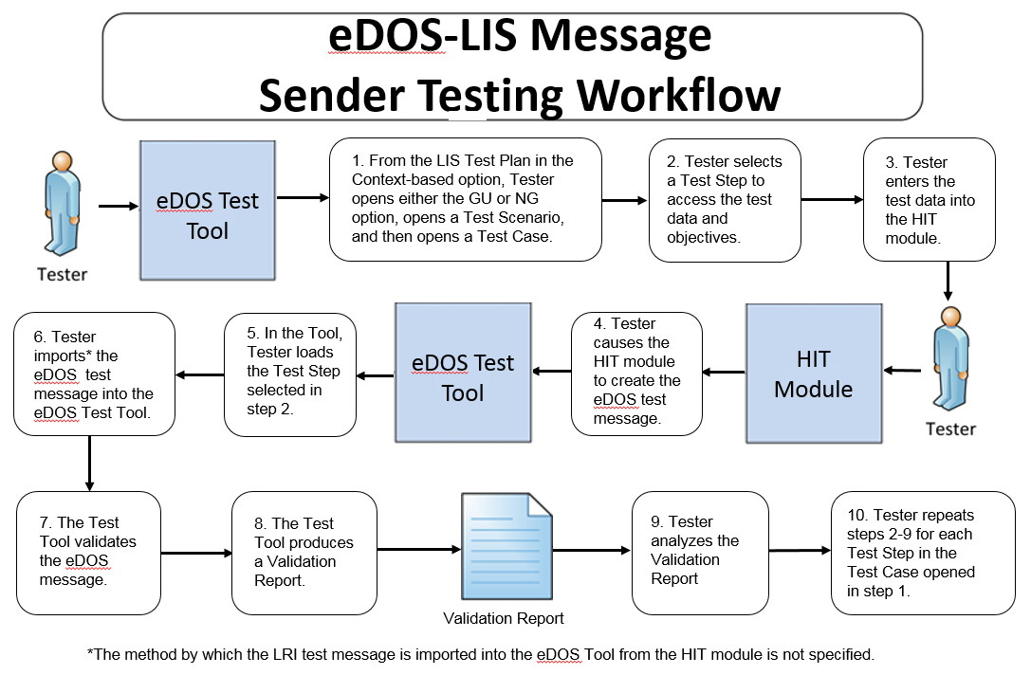

The instructions in the testing process listed below reference the numbered test steps in Figure 1.

Required Vendor Information
- Vendor shall identify the Health IT Module function(s) that are available to 1) create laboratory compendium messages using the test data, and 2) import the laboratory compendium messages into the NIST Test Tool
- Vendor shall provide the mechanism necessary to capture and import the laboratory compendium messages
- Vendor shall declare conformance to either the EDOS_GU_COMPONENT or the EDOS_NG_COMPONENT

Required Testing Actions
- Using the Context-based capability provided in the Tool identified in the Conformance Test Tools section of this testing process document, the Tester shall access the LIS Test Plan, shall open either the GU or NG option based on the vendors declared conformance profile, shall open a Test Scenario, and then shall open a Test Case [Figure 1, Step 1]
- The Tester shall select a Test Step [Figure 1, Step 2]
- Using the capabilities in the Health IT Module, the Tester shall
  - Input the provided test data for the selected Test Step using the Test Data Specification provided in the Tool for the Test Step (input can be performed using a manual or automated process) [Figure 1, Step 3]
- Cause the Module to generate the indicated eDOS message [Figure 1, Step 4]
- In the NIST Tool, the Tester shall load the selected Test Step and import the eDOS message generated by the Health IT Module [Figure 1, Steps 5, & 6]
- The NIST Tool validates the message and produces a Validation Report [Figure 1, Steps 7 & 8]
- Using the Inspection Test Guide, the Tester shall verify that the eDOS message is conformant to the eDOS IG and that the message includes the specified laboratory compendium information
- The Tester shall repeat Required Testing Actions 2 – 6 using the next sequential Test Step until all Test Steps in the opened Test Case are completed [Figure 1, Step 10]
(Note: for the Smoke Test, after testing of the first Initial Load Test Step is completed the Tester shall proceed with eDOS-LIS_DTR – 2 for testing of the Acknowledgment (MFK) message corresponding to that first Initial Load Test Step; then the Tester shall proceed with the Required Testing Actions 2 – 6 in eDOS-LIS_DTR – 1 for the next Initial Load Test Step, followed by eDOS-LIS_DTR – 2 for testing of the MFK message corresponding to that Initial Load Test Step, and so forth until all Test Steps in the Smoke Test are completed)

Inspection Test Guide
- Using the Validation Report produced by the NIST Tool, the Tester shall analyze the Report and verify that the message created by the Health IT Module meets the conformance requirements in the eDOS IG [Figure 1, Step 9]

eDOS-LIS_DTR – 2: Receive eDOS Acknowledgement Messages

Figure 2 Receive eDOS Acknowledgement Messages Testing Workflow
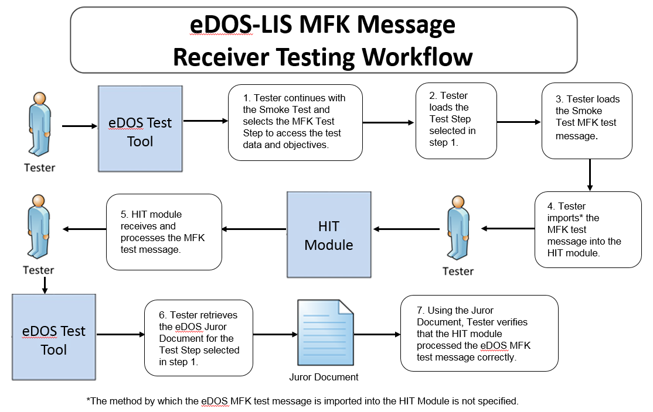

The instructions in the testing process listed below reference the numbered test steps in Figure 2.

Required Vendor Information
- The Vendor shall identify the HIT module function(s) that are available to verify that an Acknowledgement (MFK) message has been received and processed
- Vendor shall provide the mechanism necessary to capture and import the MFK messages

Required Testing Actions
- Continuing with the Smoke Test in the Context-based capability, the Tester shall select the next MFK message Test Step listed in the NIST Tool (which is functioning as an EHR-S) corresponding to the Initial Load Test Step just completed [Figure 2, Step 1]
- The Tester shall load the Test Step in the NIST Tool [Figure 2, Step 2]
- The Tester shall load the eDOS MFK message for the selected Test Step and shall import the test message into the Module [Figure 2, Steps 3 & 4]
- Using the capabilities in the HIT Module, the Tester shall observe the Module receiving and processing the eDOS MFK message that was loaded and imported [Figure 2, Step 5]
- The Tester shall retrieve the eDOS Juror Document from the NIST Tool for the Test Step selected in step 1 [Figure 2, Step 6]
- Using the Inspection Test Guide, the Tester shall verify that the HIT Module processed the MFK message correctly

Inspection Test Guide
- Using the functions in the HIT Module, the provided example MFK message, and the Test Step-specific Juror Document retrieved from the NIST Tool, the Tester shall verify that the Module received and processed the MFK message according to the conformance requirements in the eDOS IG [Figure 2, Step 7]

Test Data
Test data are provided for the testing process to ensure that the applicable requirements identified in the conformance criteria can be adequately evaluated, as well as to provide consistency in the testing process across multiple testing entities. The provided test data focus on evaluating the basic capabilities required of the Health IT Module, rather than exercising the full breadth/depth of capability that installed Health IT Modules might be expected to support. The test data are formatted for ease of use by the Tester during the testing process; the format is not intended to prescribe the design of the display presented to the end-user for viewing the data. No additional requirements should be drawn from the format.

The Tester shall use and apply the provided test data during the testing, without exception, unless one of the following conditions exists:
- The Tester determines that the Health IT Module is sufficiently specialized that the provided test data need to be modified in order to conduct an adequate test. Having made the determination that some modification to the provided test data is necessary, the Tester shall record the modifications made as part of the test documentation.
- The Tester determines that the LOINC or SNOMED CT code in a message created by the Health IT Module is a valid code for a data item (e.g., lab test) even though it is different from the LOINC or SNOMED CT code provided for that data item in the test data for that message

Any departure from the provided test data shall focus on meeting the basic capabilities required of the Health IT Module relative to the conformance criteria rather than exercising the full breadth/depth of capability that the installed Health IT Module might be expected to support.

The testing process requires that the applicable test data be entered into the Health IT Module being evaluated for conformance. The intent is that the Tester performs or observes the process of entering the test data in order to ensure that the data are correctly entered as specified in the testing process.

For conformance testing, the primary purpose of the provided test data is to assist the Tester in verifying that the vendor’s Module is capable of supporting the required functions. The clinical test data are relevant for the given Test Stories; however, these data should not be expected to represent standards of practice.

Test data for conformance testing related to the eDOS-LIS Transmit laboratory order compendium criterion are available in the NIST eDOS Test Tool (see the Conformance Test Tools section of this testing process document for instructions on how to access the Test Tool).

Navigating a Test Case
An eDOS-LIS Test Case contains multiple Test Steps, and each Test Step includes a Test Story, a Test Data Specification, a Message Content Data Sheet, an Example HL7 Message, and, where applicable, a Juror Document. All of these artifacts are accessible via the NIST Tool.
- The Test Story describes a real-world situation that provides the context for the Test Step, as well as providing Test Objectives, Comments, and Pre- and Post-Conditions.
- The Test Data Specification provides the data associated with the Test Story and lists the information that would typically be available for a given situation in a clinical setting. Together, the Test Story and the Test Data Specification provide sufficient information for the Testers and Health IT Module Vendors to enter into the Module in order to create the eDOS message for a particular Test Step. The message is to be created using these data and the Health IT Module functions.
- The Message Content Data Sheet shows a conformant message instance for the Test Step. The message content is organized in a table format that provides the HL7 v2 message elements and the data associated with the message elements for a given Test Step. The Message Content Data Sheet may provide assistance to the Tester and Health IT Module Vendor for resolving issues discovered during conformance testing. This data sheet can be thought of as the “answer” to the scenario (“question”) provided by the Test Story and the Test Data Specification.
- The Example HL7 Message shows a conformant encoded eDOS message for the Test Step.
- The Juror Documents for the Acknowledgment Test Steps in the Smoke Test provide very basic instructions to the Tester for use during conformance testing when assessing the Health IT Module’s ability to receive and process an eDOS Acknowledgement message with no errors that is sent by an EHR. The HIT Module need not make a positive notification visible in the system indicating that the Acknowledgement message was processed correctly. The format of the Juror Document is for ease-of-use by the Tester and does not indicate how the Health IT Module display must be designed.

Artifacts for the Test Step-specific Test Story, Test Data Specification, Message Content Sheet, Example HL7 Message, and Juror Document are provided via the tabs that are displayed when a user selects a Test Step in the Context-based feature of the Test Tool. These artifacts also are available in PDF files accessible for downloading via the tabs displayed with each Test Step as well as via the Test Tool Documentation tab.

The eDOS Implementation Guide defines
- Four message types that are relevant for conformance testing
- Four Acknowledgement message types that are relevant for conformance testing
- Two eDOS Profile options that are relevant for eDOS-LIS Context-based Validation.
See the Informative Test Description section for details about these message types and Profile options

For the purpose of conformance testing, the Vendor must declare conformance to either the EDOS_GU_COMPONENT or the EDOS_NG_COMPONENT—only one is required. Test Cases and/or Test Steps (and hence specific test data) are provided for each profile option.

Table 1 (eDOS Test Scenarios and Associated Test Cases and Test Steps) lists the three Test Scenarios in the Context-based eDOS-LIS Test Plan and identifies the Test Cases and Test Steps for each scenario. For this test procedure, the Tester shall execute all three Test Scenarios listed below and all of their associated Test Cases and Test Steps:

Table 1: eDOS Test Scenarios and Associated Test Cases and Test Steps

Test Scenarios | NG Test Cases | NG Test Steps | GU Test Cases | GU Test Steps
EDOS 0 | Smoke test | EDOS_0.0_1.1-M08_NG  (Initial upload, 2 individual observations)  MFK_0.0_1.1-MFK_M08_NG  (Acknowledgement)  EDOS_0.0_2.1-M10_NG  (Initial upload, single panel)  MFK_0.0_2.1-MFK_M10_NG  (Acknowledgement)  EDOS_0.0_3.1-M04_NG  (Initial upload, charge code for a panel)  MFK_0.0_3.1-MFK_M04_NG  (Acknowledgement)  EDOS_0.0_4.1-M18_NG  (Initial upload of a list of approved coverage for a panel)  MFK_0.0_4.1-MFK_M18_NG  (Acknowledgement) | Smoke test | EDOS_0.0_1.1-M08_GU  (Initial upload, 2 individual observations)  MFK_0.0_1.1-MFK_M08_GU  (Acknowledgement)  EDOS_0.0_2.1-M10_GU  (Initial upload, single panel)  MFK_0.0_2.1-MFK_M10_GU  (Acknowledgement)  EDOS_0.0_3.1-M04_GU  (Initial upload, charge code for a panel)  MFK_0.0_3.1-MFK_M04_GU  (Acknowledgement)  EDOS_0.0_4.1-M18_GU  (Initial upload of a list of approved coverage for a panel)  MFK_0.0_4.1-MFK_M18_GU  (Acknowledgement)
EDOS 1 | Initial load | EDOS_1.0_1.1-M08_NG  (Initial upload, individual observations)  EDOS_1.0_2.1-M10_NG  (Initial upload, panels and profiles)  EDOS_1.0_3.1-M04_NG  (Initial upload, charge codes for orderable tests and panels)  EDOS_1.0_4.1-M18_NG  (Initial upload, approved coverage info for orderable tests and panels for multiple insurance companies)  EDOS_1.0_5.1-M18_NG  (Initial upload, limited coverage info for orderable tests and panels for multiple insurance companies) | Initial load | EDOS_1.0_1.1-M08_GU  (Initial upload, individual observations)  EDOS_1.0_2.1-M10_GU  (Initial upload, panels and profiles)  EDOS_1.0_3.1-M04_GU  (Initial upload, charge codes for orderable tests and panels)  EDOS_1.0_4.1-M18_GU  (Initial upload, approved coverage info for orderable tests and panels for multiple insurance companies)  EDOS_1.0_5.1-M18_GU  (Initial upload, limited coverage info for orderable tests and panels for multiple insurance companies)
EDOS 2 | Update deactivate | EDOS_2.0_1.1-M08_NG  (Deactivate individual observation test no longer offered)  EDOS_2.0_2.1-M10_NG  (Deactivate panel/profile test no longer offered)  EDOS_2.0_3.1-M04_NG  (Deactivate charge codes of tests no longer offered)  EDOS_2.0_4.1-M18_NG  (Update approved coverage info for deactivated tests) | Update deactivate | EDOS_2.0_1.1-M08_GU  (Deactivate individual observation test no longer offered)  EDOS_2.0_2.1-M10_GU  (Deactivate panel/profile test no longer offered)  EDOS_2.0_3.1-M04_GU  (Deactivate charge codes of tests no longer offered)  EDOS_2.0_4.1-M18_GU  (Update approved coverage info for deactivated tests)
 | Update add | EDOS_2.1_1.1-M08_NG  (Add new individual observations)  EDOS_2.1_2.1-M10_NG  (Add new panels)  EDOS_2.1_3.1-M04_NG  (Add charge codes for newly added individual tests and panels)  EDOS_2.1_4.1-M18_NG  (Add approved coverage info for added tests and panels) | Update add | EDOS_2.1_1.1-M08_GU  (Add new individual observations)  EDOS_2.1_2.1-M10_GU  (Add new panels)  EDOS_2.1_3.1-M04_GU  (Add charge codes for newly added individual tests and panels)  EDOS_2.1_4.1-M18_GU  (Add approved coverage info for added tests and panels)
 | Update revise | EDOS_2.2_1.1-M08_NG  (Revision info about individual observations)  EDOS_2.2_2.1-M10_NG  (Revisions to a panel)  EDOS_2.2_3.1-M04_NG  (Revisions to charge codes for orderable tests and panels)  EDOS_2.2_4.1-M18_NG  (Revision to approved coverage info for a test) | Update revise | EDOS_2.2_1.1-M08_GU  (Revision info about individual observations)  EDOS_2.2_2.1-M10_GU  (Revisions to a panel)  EDOS_2.2_3.1-M04_GU  (Revisions to charge codes for orderable tests and panels)  EDOS_2.2_4.1-M18_GU  (Revision to approved coverage info for a test)
 | Update reactivate | EDOS_2.3_1.1-M08_NG  (Reactivate info for individual observations)  EDOS_2.3_2.1-M10_NG  (Reactivate info for panels and panel elements)  EDOS_2.3_3.1-M04_NG  (Reactivate charge codes)  EDOS_2.3_4.1-M18_NG  (Update approved coverage info for reactivated tests) | Update reactivate | EDOS_2.3_1.1-M08_GU  (Reactivate info for individual observations)  EDOS_2.3_2.1-M10_GU  (Reactivate info for panels and panel elements)  EDOS_2.3_3.1-M04_GU  (Reactivate charge codes)  EDOS_2.3_4.1-M18_GU  (Update approved coverage info for reactivated tests)
 | Update combo | EDOS_2.4_1.1-M08_NG  (Combination update: addition, revision, deactivation of info for individual observations)  EDOS_2.4_2.1-M10_NG  (Combination update: addition, revision, deactivation of info of panels and panel elements)  EDOS_2.4_3.1-M04_NG  (Combination update: addition, revision, deactivation of info of charge codes)  EDOS_2.4_4.1-M18_NG  (Updates limited coverage information for orderable tests and panels) | Update combo | EDOS_2.4_1.1-M08_GU  (Combination update: addition, revision, deactivation of info for individual observations)  EDOS_2.4_2.1-M10_GU  (Combination update: addition, revision, deactivation of info of panels and panel elements)  EDOS_2.4_3.1-M04_GU  (Combination update: addition, revision, deactivation of info of charge codes)  EDOS_2.4_4.1-M18_GU  (Updates limited coverage information for orderable tests and panels)
 | Update revise postCombo | EDOS_2.5_1.1-M08_NG  (Changes individual observation that was part of a previous update)  EDOS_2.5_2.1-M10_NG  (Changes a panel that was part of a previous update)  EDOS_2.5_3.1-M04_NG  (Changes a charge component that was part of a previous update)  EDOS_2.5_4.1-M18_NG  (Changes limited coverage info for new orderable tests and panels) | Update revise postCombo | EDOS_2.5_1.1-M08_GU  (Changes individual observation that was part of a previous update)  EDOS_2.5_2.1-M10_GU  (Changes a panel that was part of a previous update)  EDOS_2.5_3.1-M04_GU  (Changes a charge component that was part of a previous update)  EDOS_2.5_4.1-M18_GU  (Changes limited coverage info for new orderable tests and panels)

How to Interpret the Message Content Data Sheet
The Message Content Data Sheet indicates the location and data of the message for a particular Test Step. The Message Content Data Sheet can be used to assist the Tester in loading the HIT Module with the Test Step-specific data and provides a classification of the data. This classification indicates the type and the expected source of the data. How the data are classified is directly related to how the message content is validated by the Tool. In some cases, the validator is examining the message element for the prentesence or absence of data whereas in other cases it is examining the message element for both the presence of data and exact content. Table 2 shows a portion of an eDOS Message Content Data Sheet.

Table 2 Message Content Data Sheet Excerpt for a CDM Segment in an eDOS Message
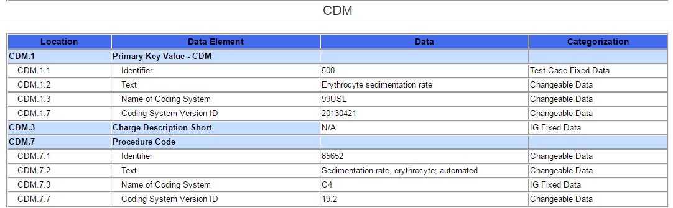

The information in the Location column indicates the canonical element location in the HL7 v2 message. For example, CDM-1.2 represents the 2nd component in the 1st field of the CDM segment. The Data Element column indicates the name of the data element as specified by the Profile contained in the eDOS Implementation Guide.

The Test Data column provides the expected data (if applicable) for that message element. The Categorization column indicates the validation category of the data. Table 3 lists the test data categorization options, a description of the categorization, and how each data category is being validated. Additional information about the test data Categories is available in the Understanding eDOS Messaging Conformance Testing document, which is accessed via the Documentation tab in the eDOS Test Tool.

Table 3 Description of Data Classification and Validation

Data Categorization | Description | Validation
Configurable | Data typically that are configured by the system  (customer-definable). Example data is provided. | Validate for the presence of data
System Generated | Data typically generated automatically by the system, e.g., message time. Example data is  provided. | Validate for the presence of data
IG Fixed | Data that are fixed by the implementation guide;  data can’t be changed. Specific data is provided. | Validate for the presence and data content
Test Case Fixed | Data that are specific and fixed by the test case; data should not be changed. Specific data is provided | Validate for the presence and selectively validate for data content
Changeable | Data where the exact content is not relevant for the test case and can be changed for the purposes of testing. Example data is provided. | Validate for the presence of data

The Test Cases and the context-based validation test tool are tightly-coupled. In addition to validating message conformance, the test tool performs selective content validation based on the Test Story and Test Data Specification provided. Deviation from the test data may cause the test tool to issue Errors. For this reason, the Tester should use the test data as specified.

The test tool is designed to support the specific information provided in the context-based test cases. If the test tool issues an error for a message instance that the vendor asserts as conformant to the implementation guide, the Vendor shall provide evidence of equivalency to the Tester.

Conformance Test Tools
The following testing tool is available to evaluate conformance to the standards referenced in this testing process document:
- NIST HL7 v2 Validation tool - Laboratory Test Compendium Framework R2, Release 1.1 – US Realm, an HL7 v2 messaging validation tool; designed to support the NIST conformance testing process
  - The tool is available as a Web Application
- The application can be downloaded for local installation
- The NIST Laboratory Test Compendium test tool Web application is available at:
http://hl7v2-edos-r1-testing.nist.gov/edos-r2/#/home

Support for this tool is available by submitting questions to the following user’s group:
https://groups.google.com/forum/#!forum/hl7v2-lab-compendium-testing

Inquiries may also be sent to this user group via email: hl7v2-lab-compendium-testing@googlegroup.com

Several browsers may be used to access the eDOS Tool: Chrome (Recommended), Firefox (Recommended), Safari, and IE 9+ are supported.

The following information is provided to assist the Tester in interpreting the Validation Reports generated by the eDOS Tool:

The Context-based capability in the Tool evaluates conformance requirements that are specified or have been derived from the standards and implementation guides identified in the conformance criteria and the test data provided for this testing process. The Test Tool evaluates the submitted HL7 message for each conformance requirement, and then produces a Validation Report.

The Tester should consider a Report that contains only Warning and Alert messages to be indicative of a sufficient level of conformance to the standard and test data expectations. If reported, Errors should be considered significant departures from the standard or test data requirements, and these Errors must be corrected in order to claim conformance. Testers will need to further analyze each Error to determine if, in the context of meeting the conformance criterion, the Error results in a failure of the testing process by the Health IT Module.

The NIST context-based testing performs specific content validation depending on the Category assigned to the Data Elements in the message (see How to Interpret the Message Content Data Sheet section for more details). In some cases, in order to perform this type of validation the NIST Tool expects the repeatable fields/segments/segment groups in the message to be sequenced in a certain order. The complexity of automatically evaluating specific content necessitates this approach. If the Message Validation Result generated by the NIST Tool indicates content-related errors, the Tester may change the order of the fields/segments/segment groups in the test message to match the Test Step once the message has been loaded into the Message Content window of the Test Tool. These kinds of content-related errors do not imply a failure of the vendor product nor a requirement to create the message with the fields/segments/segment groups in a certain order (beyond the base message structure).

Document History

Version Number | Description of Change | Date Published
1.0 | Approved Normative Test Process Document | July 18, 2016
1.1 | Informative Test Description Section  - MFN^M04^MFN_M04 – Charge Description Master File Message (« M04 »)  Changed to  - MFN^M04^MFN_M04 – Charge Description Master File Message (“M04”)  - MFN^M18^MFN_M18 – Test/ Observation (Payer) Master File Message (« M18 »)  Changed to  - MFN^M18^MFN_M18 – Test/ Observation (Payer) Master File Message (“M18”) | July 27, 2016
1.2 | Informative Test Description Section  - Deleted incorrect Step 5 in the list of Test Scenarios and their associated Test Cases and Test Steps for this Test Scenario:  - EDOS 2 – Update Test Cases – typically populated eDOS messages  Deactivate  Step 5: Initial upload of limited coverage information for orderable tests and panels for multiple insurance companies (sent from LIS or EHR-S lab module) | September 14, 2016

Minimally populated means the eDOS example messages contain single occurrences of all required ("R") elements
Maximally populated means the eDOS example messages contain all the R, RE, C(a/b) elements defined in the implementation guide
Typically populated means the eDOS example messages contain data that are routinely sent whether the data element is R (Required) or RE (Required, but may be empty)
During conformance testing, the mechanism by which the laboratory compendium test message is imported (sent) from or to the Health IT Module being tested is not specified. The Tester may have their own utility, they may allow the Module vendor to use a utility created by that vendor, or the message can be cut from the Module and pasted into the NIST Test Tool or cut from the NIST Test Tool and pasted into the Module. For conformance testing, the key requirement is for the Module to demonstrate real time/dynamic import.

